See this is our github
https://github.com/SyedAmaan001/Sagarvaani
go through this then
go through this inspo
https://cosmoq.framer.website/
see this is a a website I want to build
already I have built something
I want to add some changes
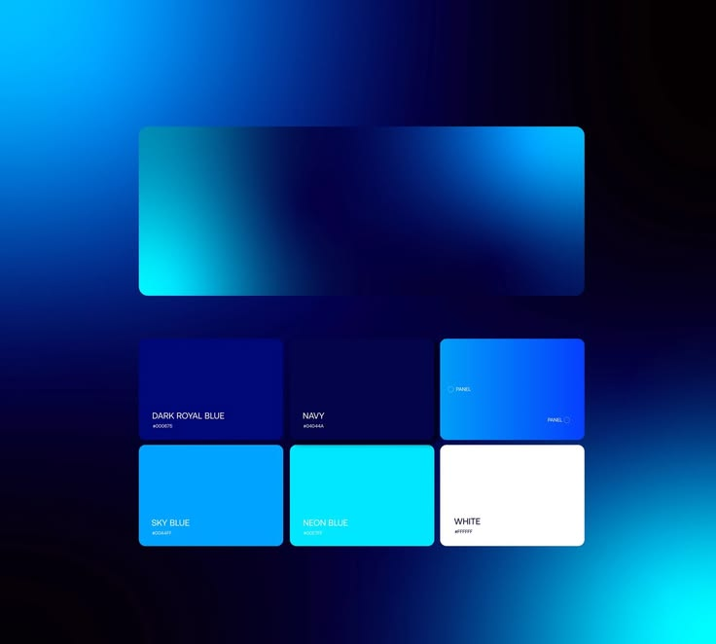
see this will be our colour palette

this will be our main font use it for adding creative part

use this for other main part of the text

use this for body and all
ok now lets see
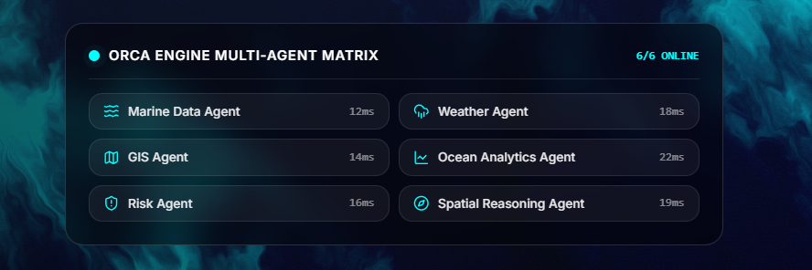
make this like this
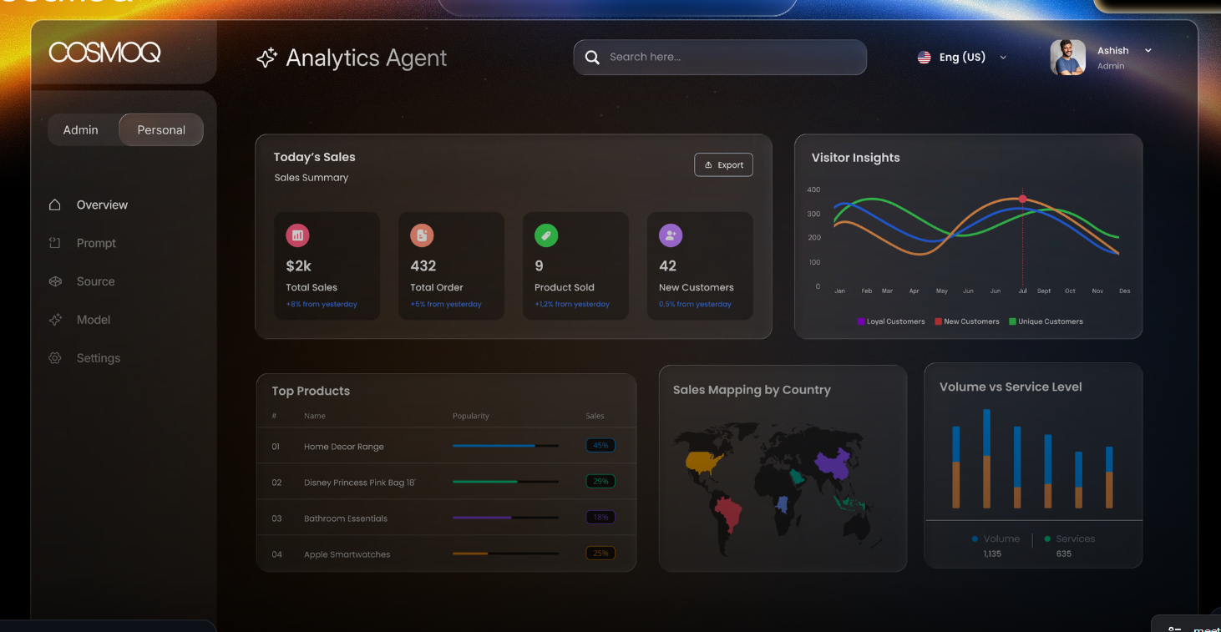
I want this instead of the below one , what we have
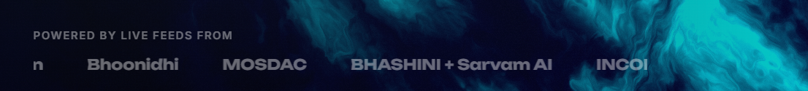
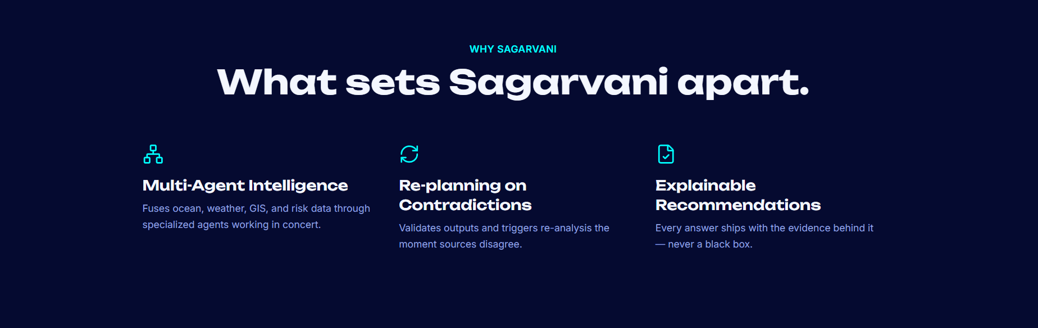
for this section , I want to add this here
npx shadcn@latest add @componentry/scroll-split-card
"use client"

import { useRef } from "react"
import { ScrollSplitCard } from "@/components/ui/scroll-split-card"

export function Example() {
const containerRef = useRef<HTMLDivElement>(null)

return (
<div
ref={containerRef}
data-lenis-prevent
className="relative h-[100dvh] w-full overflow-y-auto overscroll-contain [&::-webkit-scrollbar]:hidden [-ms-overflow-style:none] [scrollbar-width:none]"
>
<ScrollSplitCard
containerRef={containerRef}
imageSrc="https://images.unsplash.com/photo-1773058373644-74e4120bfc77?q=80&w=2832&auto=format&fit=crop&ixlib=rb-4.1.0&ixid=M3wxMjA3fDB8MHxwaG90by1wYWdlfHx8fGVufDB8fHx8fA%3D%3D"
cards={[
{
title: "Going Zero to One",
description: "If you're navigating a new business... breaking into a new market.",
bgColor: "#e2e2e2",
textColor: "#111111"
},
{
title: "Scaling from One to N",
description: "If you've achieved Product/Market Fit...",
bgColor: "#1a5bcf",
textColor: "#ffffff"
},
{
title: "Need Quick Solutions",
description: "If you know exactly what you want and need...",
bgColor: "#1c1c1c",
textColor: "#ffffff"
}
]}
/>
</div>
)
}
# Scroll Split Card

A scroll-driven interactive card component that separates into three panels and flips to reveal custom content, inspired by high-end landing page motion.

## Installation

```bash
npx componentry@latest add scroll-split-card
```

## Usage

```tsx
"use client"

import { useRef } from "react"
import { ScrollSplitCard } from "@/components/ui/scroll-split-card"

export function Example() {
const containerRef = useRef<HTMLDivElement>(null)

return (
<div
ref={containerRef}
data-lenis-prevent
className="relative h-[100dvh] w-full overflow-y-auto overscroll-contain [&::-webkit-scrollbar]:hidden [-ms-overflow-style:none] [scrollbar-width:none]"
>
<ScrollSplitCard
containerRef={containerRef}
imageSrc="https://images.unsplash.com/photo-1773058373644-74e4120bfc77?q=80&w=2832&auto=format&fit=crop&ixlib=rb-4.1.0&ixid=M3wxMjA3fDB8MHxwaG90by1wYWdlfHx8fGVufDB8fHx8fA%3D%3D"
cards={[
{
title: "Going Zero to One",
description: "If you're navigating a new business... breaking into a new market.",
bgColor: "#e2e2e2",
textColor: "#111111"
},
{
title: "Scaling from One to N",
description: "If you've achieved Product/Market Fit...",
bgColor: "#1a5bcf",
textColor: "#ffffff"
},
{
title: "Need Quick Solutions",
description: "If you know exactly what you want and need...",
bgColor: "#1c1c1c",
textColor: "#ffffff"
}
]}
/>
</div>
)
}
```

---

_Component from [Componentry](https://componentry.dev/docs/components/scroll-split-card)_
then
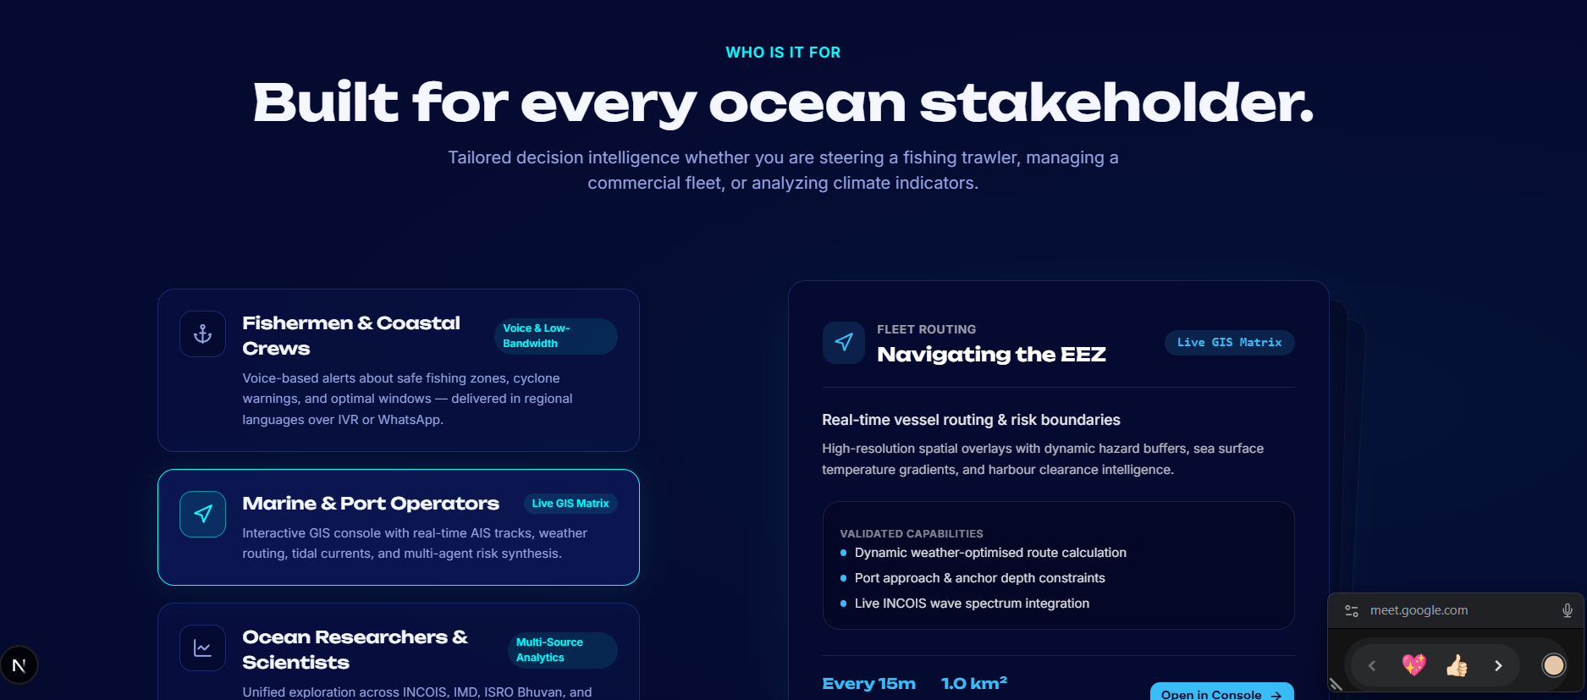
here I want to add
npx shadcn@latest add @componentry/case-study-flip-stack
import { CaseStudyFlipStack } from "@/components/ui/case-study-flip-stack"
export default function WorkPage() {
return (
<CaseStudyFlipStack
items={[
{
eyebrow: "Fintech",
title: "Boosted conversion by 42% with a product-led redesign",
description: "We rebuilt onboarding around the moments that matter.",
image: "/work/fintech.jpg",
imageAlt: "Portrait from the fintech campaign",
background: "#a94808",
foreground: "#fff7ed",
},
{
eyebrow: "Hospitality",
title: "A slower digital experience for a faster-growing retreat",
description: "A cinematic booking journey with a stronger sense of place.",
image: "/work/retreat.jpg",
imageAlt: "A mountain retreat at dusk",
background: "#067b8f",
foreground: "#ecfeff",
},
]}
/>
)
}
# Case Study Flip Stack

An editorial, scroll-driven case study stack where each full-width card folds upward to reveal the next story beneath it.

## Installation

```bash
npx componentry@latest add case-study-flip-stack
```

**Dependencies:** framer-motion

## Source Code

```tsx
"use client";

import { cn } from "@/lib/utils";
import {
motion,
useMotionTemplate,
useReducedMotion,
useScroll,
useSpring,
useTransform,
type MotionValue,
} from "framer-motion";
import { useRef } from "react";

export interface CaseStudyFlipItem {
number?: string;
eyebrow: string;
title: string;
description: string;
image: string;
imageAlt: string;
background: string;
foreground?: string;
}

interface CaseStudyFlipStackProps {
items?: CaseStudyFlipItem[];
className?: string;
hint?: string;
heading?: string;
endLabel?: string;
}

const DEFAULT_ITEMS: CaseStudyFlipItem[] = [
{
eyebrow: "Fintech",
title: "Boosted conversion by 42% with a product-led redesign",
description:
"We restructured the onboarding flow and clarified the value proposition, helping the platform turn more visitors into activated users.",
image:
"https://images.unsplash.com/photo-1524504388940-b1c1722653e1?w=1400&q=90&auto=format&fit=crop",
imageAlt: "Portrait framed by tropical greenery",
background: "#a94808",
foreground: "#fff7ed",
},
{
eyebrow: "Hospitality",
title: "A slower digital experience for a faster-growing retreat",
description:
"A cinematic booking journey brings the landscape forward, simplifies room selection, and gives every stay a stronger sense of place.",
image:
"https://images.unsplash.com/photo-1500530855697-b586d89ba3ee?w=1400&q=90&auto=format&fit=crop",
imageAlt: "A person overlooking a mountain landscape",
background: "#067b8f",
foreground: "#ecfeff",
},
{
eyebrow: "Culture",
title: "Turning a living archive into something you can wander through",
description:
"We paired bold editorial typography with an intuitive collection system, making decades of work feel immediate, playful, and alive.",
image:
"https://images.unsplash.com/photo-1561214115-f2f134cc4912?w=1400&q=90&auto=format&fit=crop",
imageAlt: "Colorful artwork in a contemporary gallery",
background: "#ba075f",
foreground: "#fff1f7",
},
{
eyebrow: "Climate",
title: "Making complex energy data feel clear enough to act on",
description:
"An approachable visual system turns live infrastructure data into useful decisions for operators, partners, and the communities they serve.",
image:
"https://images.unsplash.com/photo-1497435334941-8c899ee9e8e9?w=1400&q=90&auto=format&fit=crop",
imageAlt: "Wind turbines across a green landscape",
background: "#3322a8",
foreground: "#f3f1ff",
},
];

function FlipCard({
item,
index,
total,
progress,
reduceMotion,
}: {
item: CaseStudyFlipItem;
index: number;
total: number;
progress: MotionValue<number>;
reduceMotion: boolean;
}) {
const segment = 1 / Math.max(total, 1);
const start = index * segment;
const end = Math.min(start + segment, 1);
const entryStart = Math.max(0, start - segment);
const entryEnd =
index === 0
? 0.0001
: Math.min(start, entryStart + segment * 0.7);
const exitStart = start;
const exitEnd = end;
const stackedCardGap = Math.min(24, 72 / Math.max(total - 1, 1));
const stackedOffset = index * stackedCardGap;
const restingOffset = Math.min(index * 12, 34);
const restingScale = 1 - Math.min(index * 0.012, 0.035);

const exitYPercent = useTransform(
progress,
[exitStart, exitEnd],
reduceMotion ? [0, 0] : [0, -118],
);
const exitStackOffset = useTransform(
progress,
[exitStart, exitEnd],
reduceMotion ? [0, 0] : [0, stackedOffset],
);
const exitY = useMotionTemplate`calc(${exitYPercent}% + ${exitStackOffset}px)`;
const rotateX = useTransform(
progress,
[exitStart, exitEnd],
reduceMotion ? [0, 0] : [0, 22],
);
const opacity = useTransform(
progress,
[exitStart, exitEnd],
reduceMotion ? [1, 0] : [1, 1],
);
const entryScale = useTransform(
progress,
[entryStart, entryEnd],
index === 0 ? [1, 1] : [restingScale, 1],
);
const entryY = useTransform(
progress,
[entryStart, entryEnd],
index === 0 ? [0, 0] : [restingOffset, 0],
);

return (
<motion.article
className="absolute inset-x-0 top-0 aspect-[3/4] will-change-transform sm:aspect-[1.76/1]"
style={{
y: exitY,
rotateX,
opacity,
zIndex: total - index,
transformOrigin: "50% 50%",
transformStyle: "preserve-3d",
backfaceVisibility: "hidden",
}}
>
<motion.div
className="grid h-full overflow-hidden rounded-[clamp(18px,2vw,30px)] shadow-[0_16px_50px_rgba(20,17,10,0.18)] sm:grid-cols-[1.15fr_0.85fr]"
style={{
backgroundColor: item.background,
color: item.foreground ?? "white",
y: entryY,
scale: entryScale,
transformOrigin: "50% 100%",
}}
>
<div className="flex min-w-0 flex-col p-[clamp(24px,3vw,48px)] md:pr-[clamp(22px,3vw,48px)]">
<div className="flex items-start">
<span className="text-[clamp(24px,2.5vw,36px)] font-medium leading-none tracking-[-0.06em]">
{item.number ?? String(index + 1).padStart(2, "0")}
</span>
</div>

<div className="mt-auto max-w-[46rem] pt-8">
<p className="mb-[clamp(10px,1.5vw,22px)] text-[10px] font-semibold uppercase tracking-[0.16em] opacity-70 sm:text-xs">
{item.eyebrow}
</p>
<h2 className="max-w-[16ch] text-balance text-[clamp(28px,3.25vw,48px)] font-semibold leading-[0.96] tracking-[-0.05em]">
{item.title}
</h2>
<p className="mt-[clamp(16px,1.8vw,24px)] max-w-[42rem] text-[clamp(13px,1.1vw,16px)] leading-[1.5] opacity-82">
{item.description}
</p>
</div>
</div>

<div className="relative m-[clamp(10px,1.2vw,18px)] min-h-[180px] overflow-hidden rounded-[clamp(12px,1.4vw,22px)] sm:ml-0">
<img
src={item.image}
alt={item.imageAlt}
className="h-full w-full object-cover"
loading={index < 2 ? "eager" : "lazy"}
draggable={false}
/>
<div className="pointer-events-none absolute inset-0 bg-gradient-to-tr from-black/20 via-transparent to-white/10" />
</div>
</motion.div>
</motion.article>
);
}

export function CaseStudyFlipStack({
items = DEFAULT_ITEMS,
className,
hint = "Scroll Down",
heading = "Design That Delivers.",
endLabel = "The End",
}: CaseStudyFlipStackProps) {
const stackRef = useRef<HTMLDivElement>(null);
const reduceMotion = useReducedMotion() ?? false;
const safeItems = items.length > 0 ? items : DEFAULT_ITEMS;
const { scrollYProgress } = useScroll({
target: stackRef,
offset: ["start start", "end end"],
});
const smoothProgress = useSpring(scrollYProgress, {
stiffness: 120,
damping: 22,
mass: 0.8,
restDelta: 0.0005,
});
const cardProgress = reduceMotion ? scrollYProgress : smoothProgress;

return (
<main
className={cn("relative bg-[#eeeae2] font-sans text-[#29251f]", className)}
>
<section className="relative h-[82vh] min-h-[640px] overflow-hidden px-5 sm:px-10">
<div className="absolute inset-x-0 top-[clamp(110px,16vh,165px)] flex items-center justify-center gap-[clamp(14px,2.5vw,32px)] text-[clamp(26px,3.5vw,52px)] font-medium tracking-[-0.055em]">
<motion.span
aria-hidden="true"
animate={reduceMotion ? undefined : { y: [0, 10, 0] }}
transition={{ duration: 1.4, repeat: Infinity, ease: "easeInOut" }}
>
↓
</motion.span>
<span>{hint}</span>
<motion.span
aria-hidden="true"
animate={reduceMotion ? undefined : { y: [0, 10, 0] }}
transition={{
duration: 1.4,
delay: 0.18,
repeat: Infinity,
ease: "easeInOut",
}}
>
↓
</motion.span>
</div>

<div className="absolute inset-x-5 top-[clamp(330px,43vh,440px)] flex justify-center sm:inset-x-10">
<h1 className="max-w-[18ch] text-center text-[clamp(42px,5.5vw,82px)] font-semibold leading-[0.92] tracking-[-0.06em] text-[#a94808]">
{heading}
</h1>
</div>
</section>

<div
ref={stackRef}
className="relative"
style={{ height: `${(Math.max(safeItems.length, 1) + 1) * 100}vh` }}
>
<div className="sticky top-0 flex h-screen flex-col justify-center overflow-hidden px-[clamp(14px,4vw,64px)] py-8">
<div className="relative mx-auto aspect-[3/4] w-full max-w-[860px] [perspective:800px] sm:aspect-[1.76/1]">
{[...safeItems].reverse().map((item, reverseIndex) => {
const index = safeItems.length - reverseIndex - 1;
return (
<FlipCard
key={`${item.title}-${index}`}
item={item}
index={index}
total={safeItems.length}
progress={cardProgress}
reduceMotion={reduceMotion}
/>
);
})}
</div>
</div>
</div>

<section className="flex min-h-[120vh] items-center justify-center px-5 sm:px-10">
<p className="text-center text-[clamp(54px,9vw,144px)] font-semibold leading-none tracking-[-0.07em] text-[#29251f]">
{endLabel}
</p>
</section>
</main>
);
}

```

## Usage

```tsx
import { CaseStudyFlipStack } from "@/components/ui/case-study-flip-stack"

export default function WorkPage() {
return (
<CaseStudyFlipStack
items={[
{
eyebrow: "Fintech",
title: "Boosted conversion by 42% with a product-led redesign",
description: "We rebuilt onboarding around the moments that matter.",
image: "/work/fintech.jpg",
imageAlt: "Portrait from the fintech campaign",
background: "#a94808",
foreground: "#fff7ed",
},
{
eyebrow: "Hospitality",
title: "A slower digital experience for a faster-growing retreat",
description: "A cinematic booking journey with a stronger sense of place.",
image: "/work/retreat.jpg",
imageAlt: "A mountain retreat at dusk",
background: "#067b8f",
foreground: "#ecfeff",
},
]}
/>
)
}
```

## API Reference (Props)

| Prop | Type | Default | Description |
|------|------|---------|-------------|
| `items` | `CaseStudyFlipItem[]` | - | Case studies with copy, image, accessible alt text, and card colors. |
| `hint` | `string` | `"Scroll Down"` | The animated opening instruction between the arrows. |
| `heading` | `string` | `"Design That Delivers."` | The large introduction heading shown before the card stack. |
| `endLabel` | `string` | `"The End"` | The closing message revealed after the final card stacks. |
| `className` | `string` | - | Additional classes for the scroll section container. |

---

_Component from [Componentry](https://componentry.dev/docs/components/case-study-flip-stack)_
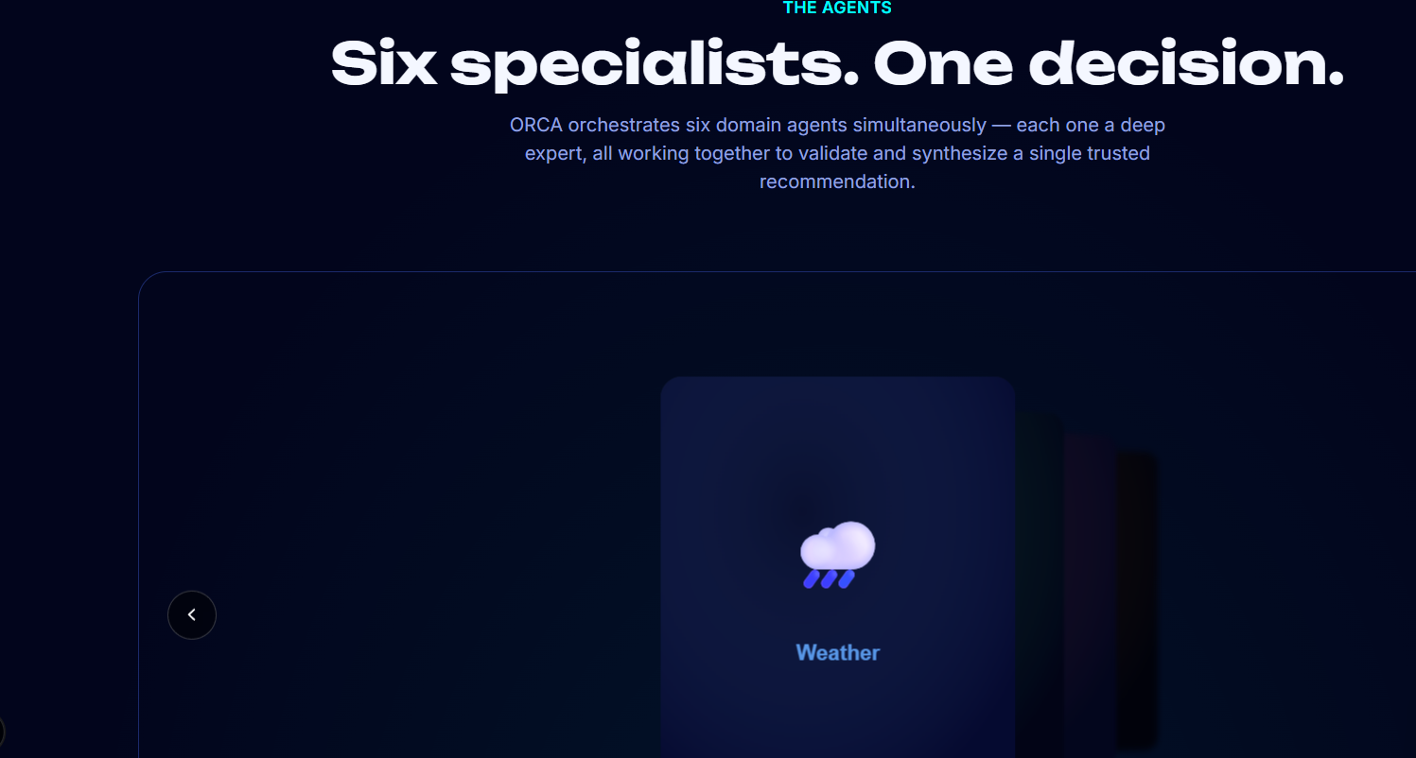
## Integrate the <DepthCarousel /> component from React Bits

You are helping integrate an open-source React component into an existing application.

### Component: DepthCarousel
### Variant: TypeScript + Tailwind
### Dependencies: gsap

---

### Usage Example
```jsx
import DepthCarousel from './DepthCarousel';

const items = [
{ image: 'https://picsum.photos/seed/a/800/1000', alt: 'One' },
{ image: 'https://picsum.photos/seed/b/800/1000', alt: 'Two' },
{ image: 'https://picsum.photos/seed/c/800/1000', alt: 'Three' },
{ image: 'https://picsum.photos/seed/d/800/1000', alt: 'Four' },
{ image: 'https://picsum.photos/seed/e/800/1000', alt: 'Five' }
];

<div style={{ height: '500px', position: 'relative' }}>
<DepthCarousel
items={items}
depth={220}
spread={90}
tilt={22}
tiltDirection="right"
perspective={1400}
visibleCards={4}
falloff={0.2}
blur={6}
autoplay
loop
/>
</div>
```

### Props
| Prop | Type | Default | Description |
|------|------|---------|-------------|
| items | Array<string | { image: string; alt?: string }> | 6 sample images | Slides to display. Pass image URLs or objects with an image URL and alt text. |
| cardWidth | number | 300 | Width of each card in pixels. |
| cardHeight | number | 380 | Height of each card in pixels. |
| radius | number | 18 | Corner rounding of the cards in pixels. |
| tint | string | "#05060a" | Colour multiplied over cards as they recede, shading the depth of the stack. |
| depth | number | 220 | Z distance in pixels between each card along the depth rail. Higher values push the stack further back. |
| spread | number | 90 | Lateral offset in pixels applied per card so the stack fans out to one side. |
| tilt | number | 22 | Degrees each receding card rotates around the vertical axis, revealing its edge. |
| tiltDirection | "left" | "right" | "right" | Which side the stack fans and tilts toward. |
| perspective | number | 1400 | CSS perspective in pixels. Lower values exaggerate the depth foreshortening. |
| visibleCards | number | 4 | How many cards deep remain visible before further ones fade out. |
| falloff | number | 0.2 | How quickly brightness, tint and blur ramp up with depth. |
| blur | number | 6 | Maximum blur in pixels applied to the furthest visible card. |
| duration | number | 700 | Length of the advance transition in milliseconds. |
| ease | string | "power3.out" | GSAP easing used for navigation transitions. |
| autoplay | boolean | false | Auto-advance the carousel, pausing on hover or focus. |
| autoplayDelay | number | 3200 | Delay between auto-advances in milliseconds. |
| loop | boolean | true | Wrap seamlessly from the last card back to the first. |
| showControls | boolean | true | Show the previous / next arrow buttons. |
| showIndicators | boolean | true | Show the dot indicators. |
| onChange | (index: number, item) => void | undefined | Called whenever the focused card changes. |

### Full Component Source
```tsx
import {
useCallback,
useEffect,
useMemo,
useRef,
useState,
PointerEvent as ReactPointerEvent,
KeyboardEvent as ReactKeyboardEvent
} from 'react';
import gsap from 'gsap';

export type DepthCarouselItem = string | { image: string; alt?: string };
type TiltDirection = 'left' | 'right';

export interface DepthCarouselProps {
items?: DepthCarouselItem[];
cardWidth?: number;
cardHeight?: number;
radius?: number;
tint?: string;
depth?: number;
spread?: number;
tilt?: number;
tiltDirection?: TiltDirection;
perspective?: number;
visibleCards?: number;
falloff?: number;
blur?: number;
duration?: number;
ease?: string;
autoplay?: boolean;
autoplayDelay?: number;
loop?: boolean;
showControls?: boolean;
showIndicators?: boolean;
onChange?: (index: number, item: { image: string; alt?: string }) => void;
className?: string;
}

interface CarouselConfig {
count: number;
depth: number;
spread: number;
tilt: number;
tiltDirection: TiltDirection;
visibleCards: number;
falloff: number;
blur: number;
duration: number;
ease: string;
loop: boolean;
cardWidth: number;
autoplayDelay: number;
}

interface DragState {
x: number;
startPos: number;
lastX: number;
lastT: number;
v: number;
moved: boolean;
id: number;
}

const DEFAULT_ITEMS: DepthCarouselItem[] = [
{ image: 'https://picsum.photos/seed/depth1/800/1000', alt: 'Slide 1' },
{ image: 'https://picsum.photos/seed/depth2/800/1000', alt: 'Slide 2' },
{ image: 'https://picsum.photos/seed/depth3/800/1000', alt: 'Slide 3' },
{ image: 'https://picsum.photos/seed/depth4/800/1000', alt: 'Slide 4' },
{ image: 'https://picsum.photos/seed/depth5/800/1000', alt: 'Slide 5' },
{ image: 'https://picsum.photos/seed/depth6/800/1000', alt: 'Slide 6' }
];

const clamp = (v: number, min: number, max: number) => Math.min(Math.max(v, min), max);
const normalizeItem = (it: DepthCarouselItem) => (typeof it === 'string' ? { image: it, alt: '' } : it);

const DepthCarousel = ({
items = DEFAULT_ITEMS,
cardWidth = 300,
cardHeight = 380,
radius = 18,
tint = '#05060a',
depth = 220,
spread = 90,
tilt = 22,
tiltDirection = 'right',
perspective = 1400,
visibleCards = 4,
falloff = 0.2,
blur = 6,
duration = 700,
ease = 'power3.out',
autoplay = false,
autoplayDelay = 3200,
loop = true,
showControls = true,
showIndicators = true,
onChange,
className = ''
}: DepthCarouselProps) => {
const data = useMemo(() => (Array.isArray(items) ? items : []).map(normalizeItem), [items]);
const count = data.length;

const rootRef = useRef<HTMLDivElement | null>(null);
const stageRef = useRef<HTMLDivElement | null>(null);
const cardRefs = useRef<(HTMLDivElement | null)[]>([]);
const overlayRefs = useRef<(HTMLSpanElement | null)[]>([]);

const posRef = useRef(0);
const focusRef = useRef(0);
const tweenRef = useRef<gsap.core.Tween | null>(null);
const scaleRef = useRef(1);
const cfgRef = useRef<CarouselConfig>({} as CarouselConfig);
const onChangeRef = useRef(onChange);

const dragRef = useRef<DragState | null>(null);
const wheelTimerRef = useRef<ReturnType<typeof setTimeout> | null>(null);
const autoTimerRef = useRef<ReturnType<typeof setInterval> | null>(null);
const reducedRef = useRef(false);

const [active, setActive] = useState(0);

onChangeRef.current = onChange;
cfgRef.current = {
count,
depth,
spread,
tilt,
tiltDirection,
visibleCards,
falloff,
blur,
duration,
ease,
loop,
cardWidth,
autoplayDelay
};

const layout = useCallback((pos: number) => {
const cfg = cfgRef.current;
const n = cfg.count;
if (!n) return;
const dir = cfg.tiltDirection === 'left' ? -1 : 1;
const sc = scaleRef.current;

for (let i = 0; i < n; i++) {
const el = cardRefs.current[i];
if (!el) continue;

let d = i - pos;
if (cfg.loop && n > 1) {
d = ((d % n) + n) % n;
if (d > n / 2) d -= n;
}

const back = Math.max(0, d);
const az = Math.abs(d);
const shown = az <= cfg.visibleCards + 0.5;

const tz = -cfg.depth * d;
const tx = dir * cfg.spread * d;
const ry = dir * cfg.tilt * clamp(d, 0, 1);

let opacity = d < 0 ? Math.max(0, 1 + d) : 1;
if (!shown) opacity = 0;

const brightness = Math.max(0.15, 1 - back * cfg.falloff);
const blurPx = cfg.blur > 0 ? Math.min(cfg.blur, (back / Math.max(1, cfg.visibleCards)) * cfg.blur) : 0;
const zi = Math.round(2000 - d * 20);

el.style.transform = `translate(-50%, -50%) scale(${sc}) translateX(${tx.toFixed(2)}px) translateZ(${tz.toFixed(2)}px) rotateY(${ry.toFixed(3)}deg)`;
el.style.opacity = opacity.toFixed(3);
el.style.filter = `brightness(${brightness.toFixed(3)}) blur(${blurPx.toFixed(2)}px)`;
el.style.zIndex = String(zi);
el.style.pointerEvents = shown && opacity > 0.05 ? 'auto' : 'none';

const ov = overlayRefs.current[i];
if (ov) ov.style.opacity = clamp(back * cfg.falloff * 1.25, 0, 0.86).toFixed(3);
}
}, []);

const notify = useCallback(
(idx: number) => {
setActive(idx);
onChangeRef.current?.(idx, data[idx]);
},
[data]
);

const tweenTo = useCallback(
(target: number, animate: boolean) => {
tweenRef.current?.kill();
const cfg = cfgRef.current;
const proxy = { p: posRef.current };
const dur = animate && !reducedRef.current ? cfg.duration / 1000 : 0;
tweenRef.current = gsap.to(proxy, {
p: target,
duration: dur,
ease: cfg.ease,
onUpdate: () => {
posRef.current = proxy.p;
layout(proxy.p);
},
onComplete: () => {
const n = cfg.count;
if (n > 0) posRef.current = ((posRef.current % n) + n) % n;
layout(posRef.current);
}
});
},
[layout]
);

const setFocus = useCallback(
(rawIndex: number, animate = true) => {
const cfg = cfgRef.current;
const n = cfg.count;
if (!n) return;
const idx = cfg.loop ? ((rawIndex % n) + n) % n : clamp(rawIndex, 0, n - 1);
let delta = idx - posRef.current;
if (cfg.loop && n > 1) {
delta = ((delta % n) + n) % n;
if (delta > n / 2) delta -= n;
}
tweenTo(posRef.current + delta, animate);
if (idx !== focusRef.current) {
focusRef.current = idx;
notify(idx);
}
},
[tweenTo, notify]
);

const navigateBy = useCallback((step: number) => setFocus(focusRef.current + step, true), [setFocus]);

useEffect(() => {
const root = rootRef.current;
if (!root) return;
const ro = new ResizeObserver(entries => {
const w = entries[0].contentRect.width;
const cfg = cfgRef.current;
const needed = cfg.cardWidth + Math.abs(cfg.spread) * 2 + 120;
scaleRef.current = clamp(w / needed, 0.4, 1);
layout(posRef.current);
});
ro.observe(root);
return () => ro.disconnect();
}, [layout]);

useEffect(() => {
const el = rootRef.current;
if (!el) return;
const onWheel = (e: WheelEvent) => {
const cfg = cfgRef.current;
if (cfg.count < 2) return;
e.preventDefault();
tweenRef.current?.kill();
const raw = Math.abs(e.deltaX) > Math.abs(e.deltaY) ? e.deltaX : e.deltaY;
const delta = e.deltaMode === 1 ? raw * 24 : raw;
const step = clamp(delta / (cfg.cardWidth * 0.9), -0.6, 0.6);
posRef.current += step;
layout(posRef.current);
if (wheelTimerRef.current) clearTimeout(wheelTimerRef.current);
wheelTimerRef.current = setTimeout(() => setFocus(Math.round(posRef.current), true), 130);
};
el.addEventListener('wheel', onWheel, { passive: false });
return () => {
el.removeEventListener('wheel', onWheel);
if (wheelTimerRef.current) clearTimeout(wheelTimerRef.current);
};
}, [layout, setFocus]);

const onPointerDown = useCallback((e: ReactPointerEvent<HTMLDivElement>) => {
const cfg = cfgRef.current;
if (cfg.count < 2) return;
tweenRef.current?.kill();
dragRef.current = {
x: e.clientX,
startPos: posRef.current,
lastX: e.clientX,
lastT: performance.now(),
v: 0,
moved: false,
id: e.pointerId
};
}, []);

const onPointerMove = useCallback(
(e: ReactPointerEvent<HTMLDivElement>) => {
const drag = dragRef.current;
if (!drag) return;
const cfg = cfgRef.current;
const stepPx = Math.max(cfg.cardWidth * 0.55 * scaleRef.current, 40);
const dx = e.clientX - drag.x;
if (!drag.moved && Math.abs(dx) > 4) {
drag.moved = true;
rootRef.current?.setPointerCapture(drag.id);
}
if (!drag.moved) return;
const now = performance.now();
const dt = Math.max(now - drag.lastT, 1);
drag.v = (e.clientX - drag.lastX) / dt;
drag.lastX = e.clientX;
drag.lastT = now;
posRef.current = drag.startPos - dx / stepPx;
layout(posRef.current);
},
[layout]
);

const onPointerEnd = useCallback(() => {
const drag = dragRef.current;
if (!drag) return;
dragRef.current = null;
if (!drag.moved) return;
const cfg = cfgRef.current;
const stepPx = Math.max(cfg.cardWidth * 0.55 * scaleRef.current, 40);
const projected = posRef.current - (drag.v * 180) / stepPx;
setFocus(Math.round(projected), true);
}, [setFocus]);

const onKeyDown = useCallback(
(e: ReactKeyboardEvent<HTMLDivElement>) => {
if (e.key === 'ArrowLeft') {
e.preventDefault();
navigateBy(-1);
} else if (e.key === 'ArrowRight') {
e.preventDefault();
navigateBy(1);
}
},
[navigateBy]
);

const onCardClick = useCallback(
(index: number) => {
if (dragRef.current?.moved) return;
setFocus(index, true);
},
[setFocus]
);

useEffect(() => {
reducedRef.current = typeof window !== 'undefined' && window.matchMedia('(prefers-reduced-motion: reduce)').matches;
if (!autoplay || reducedRef.current || count < 2) return;
const root = rootRef.current;
let hovered = false;
let focused = false;
const stop = () => {
if (autoTimerRef.current) clearInterval(autoTimerRef.current);
autoTimerRef.current = null;
};
const start = () => {
stop();
autoTimerRef.current = setInterval(
() => {
if (!hovered && !focused) navigateBy(1);
},
Math.max(cfgRef.current.autoplayDelay, 600)
);
};
const onEnter = () => {
hovered = true;
};
const onLeave = () => {
hovered = false;
};
const onFocusIn = () => {
focused = true;
};
const onFocusOut = () => {
focused = false;
};
root?.addEventListener('mouseenter', onEnter);
root?.addEventListener('mouseleave', onLeave);
root?.addEventListener('focusin', onFocusIn);
root?.addEventListener('focusout', onFocusOut);
start();
return () => {
stop();
root?.removeEventListener('mouseenter', onEnter);
root?.removeEventListener('mouseleave', onLeave);
root?.removeEventListener('focusin', onFocusIn);
root?.removeEventListener('focusout', onFocusOut);
};
}, [autoplay, autoplayDelay, count, navigateBy]);

useEffect(() => {
layout(posRef.current);
}, [layout, depth, spread, tilt, tiltDirection, visibleCards, falloff, blur, cardWidth, cardHeight, radius, count]);

useEffect(
() => () => {
tweenRef.current?.kill();
if (wheelTimerRef.current) clearTimeout(wheelTimerRef.current);
if (autoTimerRef.current) clearInterval(autoTimerRef.current);
},
[]
);

return (
<div
ref={rootRef}
className={`relative flex h-full min-h-[320px] w-full cursor-grab touch-pan-y select-none items-center justify-center outline-none [perspective-origin:50%_50%] active:cursor-grabbing focus-visible:rounded-xl focus-visible:outline-2 focus-visible:outline-white/50 focus-visible:[outline-offset:4px] ${className}`.trim()}
style={{ perspective: `${perspective}px` }}
role="group"
aria-roledescription="carousel"
aria-label="Depth carousel"
tabIndex={0}
onPointerDown={onPointerDown}
onPointerMove={onPointerMove}
onPointerUp={onPointerEnd}
onPointerCancel={onPointerEnd}
onKeyDown={onKeyDown}
>
<div className="absolute inset-0 [transform-style:preserve-3d]" ref={stageRef}>
{data.map((item, i) => (
<div
key={i}
className="absolute left-1/2 top-1/2 cursor-pointer overflow-hidden bg-[#0b0d12] shadow-[0_30px_60px_-20px_rgba(0,0,0,0.65),0_8px_20px_-10px_rgba(0,0,0,0.5)] [transform:translate(-50%,-50%)] [transform-origin:center] [will-change:transform,opacity,filter]"
ref={el => {
cardRefs.current[i] = el;
}}
style={{ width: cardWidth, height: cardHeight, borderRadius: radius }}
aria-roledescription="slide"
aria-label={`${i + 1} of ${count}`}
aria-hidden={active !== i}
onClick={() => onCardClick(i)}
>
<img
className="block h-full w-full select-none object-cover [pointer-events:none] [-webkit-user-drag:none]"
src={item.image}
alt={item.alt || ''}
draggable={false}
/>
<span
className="pointer-events-none absolute inset-0 opacity-0 mix-blend-multiply"
ref={el => {
overlayRefs.current[i] = el;
}}
style={{ background: tint }}
/>
</div>
))}
</div>

{showControls && count > 1 && (
<>
<button
type="button"
className="absolute left-4 top-1/2 z-[3000] grid h-[42px] w-[42px] -translate-y-1/2 place-items-center rounded-full border border-white/20 bg-[rgba(18,20,26,0.55)] text-white backdrop-blur-md transition-[background,border-color,transform] duration-200 hover:border-white/40 hover:bg-[rgba(28,31,40,0.85)] active:scale-95"
aria-label="Previous slide"
onClick={() => navigateBy(-1)}
>
<svg viewBox="0 0 24 24" width="20" height="20" aria-hidden="true">
<path
d="M15 5l-7 7 7 7"
fill="none"
stroke="currentColor"
strokeWidth="2"
strokeLinecap="round"
strokeLinejoin="round"
/>
</svg>
</button>
<button
type="button"
className="absolute right-4 top-1/2 z-[3000] grid h-[42px] w-[42px] -translate-y-1/2 place-items-center rounded-full border border-white/20 bg-[rgba(18,20,26,0.55)] text-white backdrop-blur-md transition-[background,border-color,transform] duration-200 hover:border-white/40 hover:bg-[rgba(28,31,40,0.85)] active:scale-95"
aria-label="Next slide"
onClick={() => navigateBy(1)}
>
<svg viewBox="0 0 24 24" width="20" height="20" aria-hidden="true">
<path
d="M9 5l7 7-7 7"
fill="none"
stroke="currentColor"
strokeWidth="2"
strokeLinecap="round"
strokeLinejoin="round"
/>
</svg>
</button>
</>
)}

{showIndicators && count > 1 && (
<div
className="absolute bottom-4 left-1/2 z-[3000] flex -translate-x-1/2 gap-2 rounded-full bg-[rgba(14,16,22,0.4)] px-3 py-2 backdrop-blur-sm"
role="tablist"
aria-label="Slides"
>
{data.map((_, i) => (
<button
key={i}
type="button"
role="tab"
aria-selected={active === i}
aria-label={`Go to slide ${i + 1}`}
className={`h-[7px] cursor-pointer rounded-full transition-[width,background] duration-[250ms] ${
active === i ? 'w-5 bg-white' : 'w-[7px] bg-white/30'
}`}
onClick={() => setFocus(i, true)}
/>
))}
</div>
)}
</div>
);
};

export default DepthCarousel;

```

### Integration Instructions
1. Install any listed dependencies.
2. Copy the component source into the appropriate directory in the project.
3. Import and render the component using the usage example above as a starting point.
4. Adjust props as needed for the specific use case — refer to the props table for all available options.

### More from React Bits
The full library index, including everything reactbits.dev offers, is at https://reactbits.dev/llms.txt — fetch it if this component is not the right fit or the project needs more pieces.
for this , give me prompts for generating the images for this as well
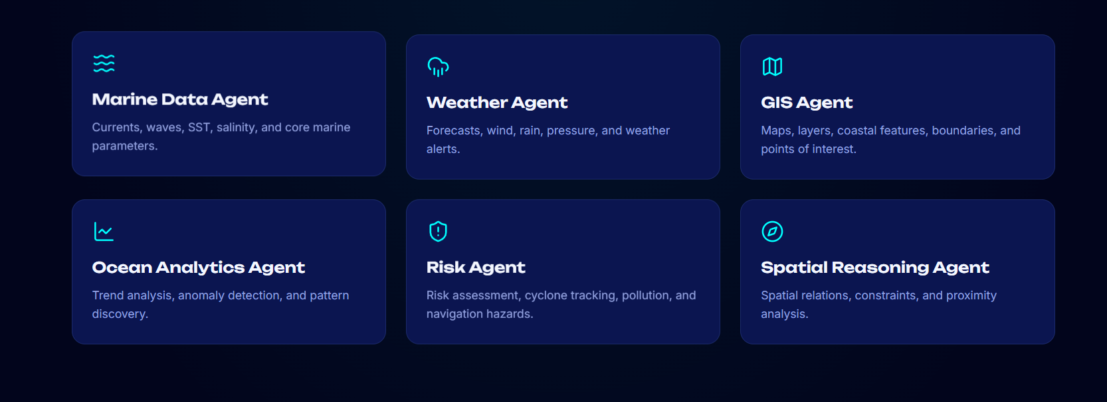
for this add the same thing , I don’t want to have two different things but the same
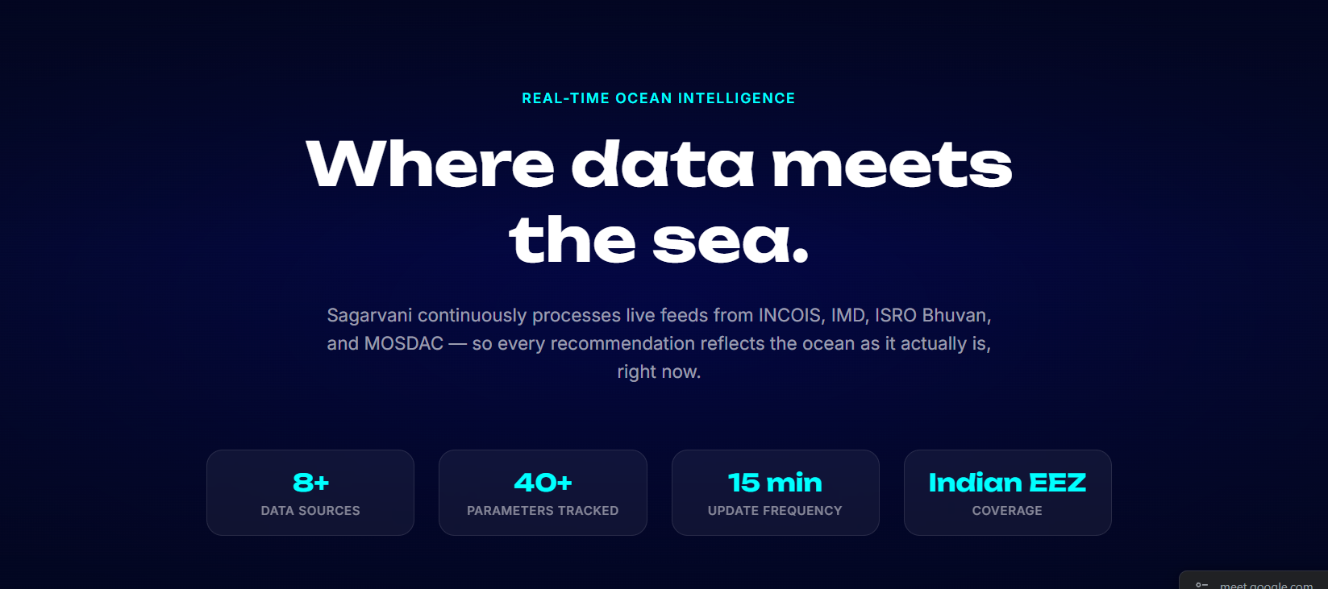
this I want to remove for now
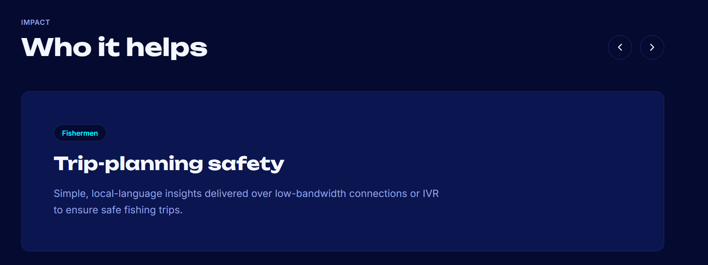
here I want to add more components , research for this thing as well , find marine stakeholders , how our product will help them , how it will benefit them
all those stuff

